DEVELOP THE WEB APPLICATION USING NODE RED

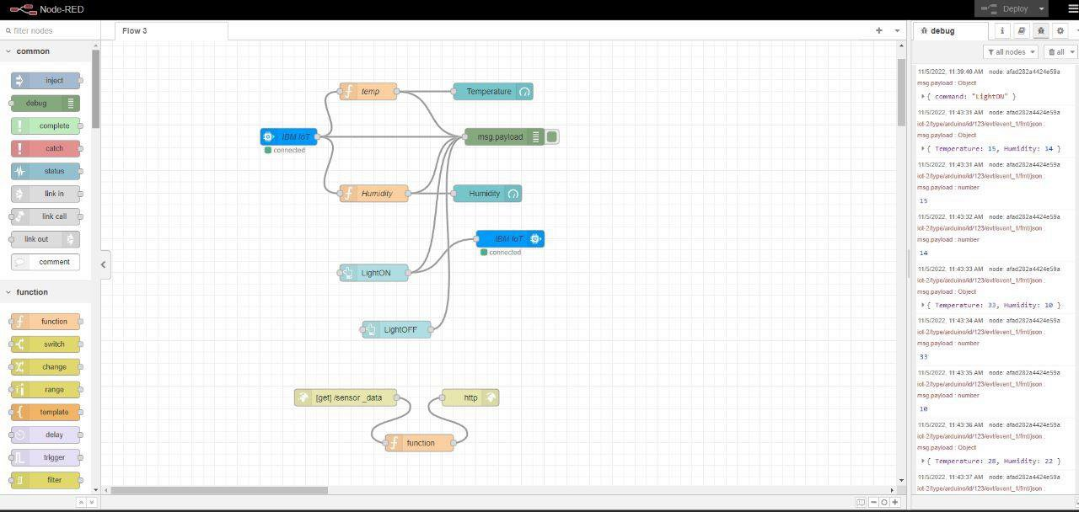
Create Node Red Flow To Send Date to Device:
Date | 15 November 2022
Team ID | PNT2022TMID44492
Project Name | Project - Signs with smart connectivity for Better road safety
Maximum Marks | 4 Marks
